Nikhil Bansal
Lab 4 Writeup
Chosen Platform: Twitter / X
Copyright Policy (Information from https://help.x.com/en/rules-and-policies/copyright-policy):
Twitter responds specifically to copyright complaints filed manually through DMCA takedown requests. Unlike YouTube, it does not have a highly specialized automatic copyright detection system except for with some livestreamed content. When content is flagged as potentially infringing by a takedown request, Twitter will respond if it meets the following criteria and does not fall under fair use: the complaint involves “allegations concerning the unauthorized use of a copyrighted image as a profile or header photo, allegations concerning the unauthorized use of a copyrighted video or image uploaded through our media hosting services, or posts containing links to allegedly infringing materials.”
If Twitter reviews a claim ticket and finds that the content in question is infringing, it will decide to remove or disable access to the material in question. The poster will then be given notice and a full copy of the complaint that led to the takedown and instructions on how to file a counter-notice. For transparency reasons, content is also publicly flagged to viewers as infringing if it is disabled.
Posters can send counter-notices through the Help Center to as a formal request to reinstate the removed material with legal consequences. Filing a counter-notice begins a legal process which involves the turnover of personal information to the copyright reporter as well as subjection to the US Federal court system. Twitter also suggests contacting the copyright holder through the contact information listed in the takedown request to have them retract their complaint. If the reporter agrees, they can submit a retraction form to Twitter to have the content reinstated and their takedown undone.
Twitter’s copyright policy is unclear about what happens to monetization for removed content, but it is likely that monetization earned on copyrighted content that is taken down is either withheld or paused.
Fair Use Experiments
I decided to upload 2 raw copyrighted clips from the movie Fury. One clip would be 10 seconds long, and another clip would be 30 seconds long (both clips are included in my github).
Clip 1:
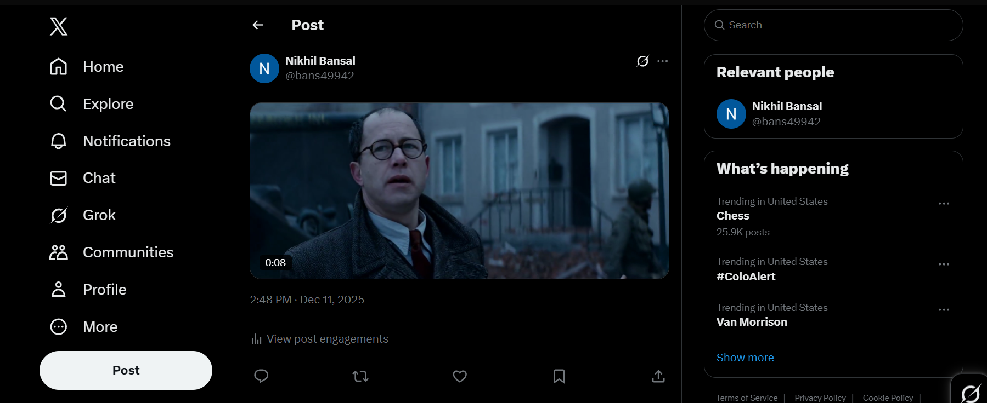
Time Until Detection: N/A
Warnings: None
Final Outcome: The content stayed up and was not flagged or reported by anyone at Twitter.
Options Presented: N/A

Clip 2:
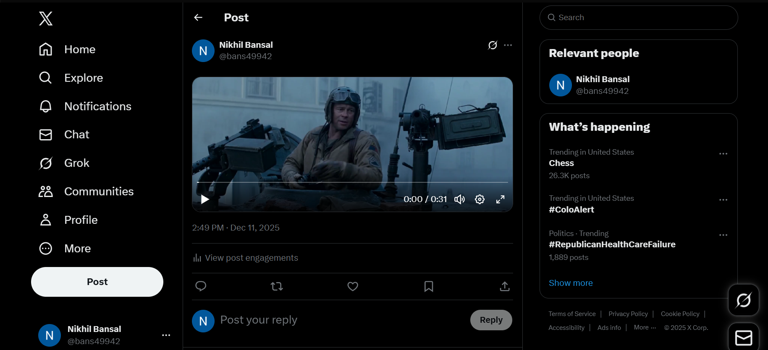
Time Until Detection: N/A
Warnings: None
Final Outcome: The content stayed up and was not flagged or reported by anyone at Twitter.
Options Presented: N/A

AI Generated Content Investigation
I decided to use direct reference images of varying degrees of similarity to the copyrighted character Pikachu. First, I had the Grok AI generate a photo of Pikachu using the prompt below:
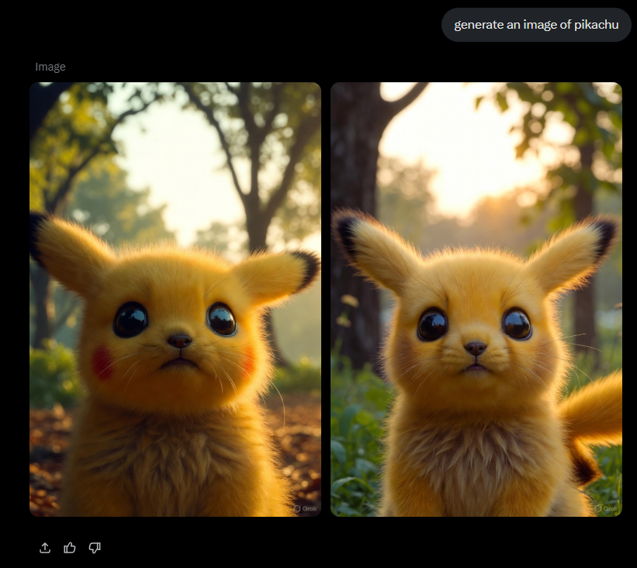
Then I had it generate another image, but this time for a character that is similar to but not exactly like Pikachu.
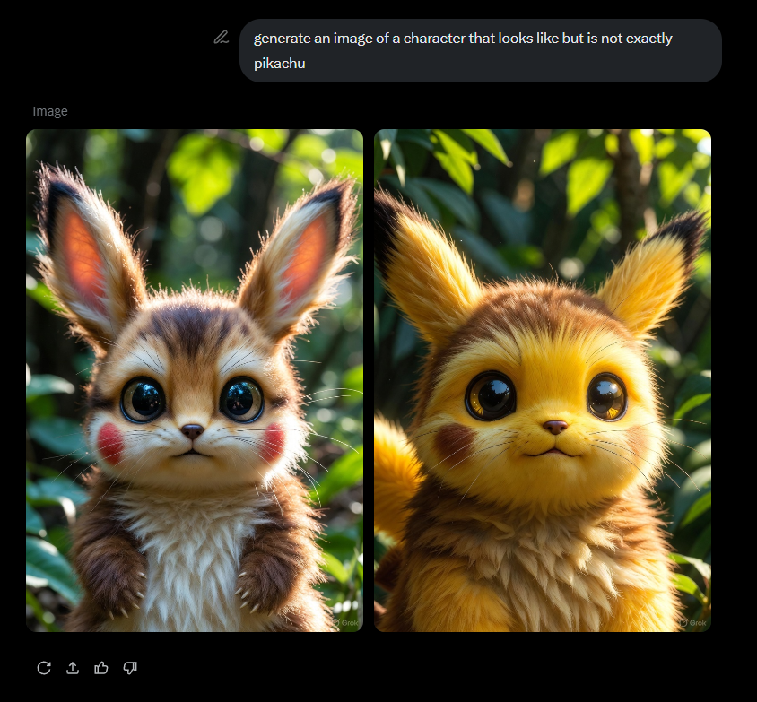
It’s worth noting that using Grok to violate copyright laws is not allowed under the xAI Terms of Service (https://x.ai/legal/terms-of-service). It is prohibited to use Grok for “Causing harm or engaging in abusive activity, including by […] Violating copyright, trademark, or other intellectual property law”.
Twitter did not end up removing either of the images I uploaded and instead was able to recognize that the images were generated with Grok:
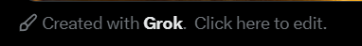
Twitter itself does allow AI content on its platform and even encourages users to post AI generated content using Grok as long as it is not infringing within the scope of copyright. However, it does not allow for AI to be used to create false personas on Twitter. As for who owns the copyright of these images, I believe that that has still yet to be decided by courts currently, although the copyright to the character of Pikachu itself is retained by the Pokémon Company.
Legal Analysis
Fair Use Factors:
- The raw copyrighted clips were not transformative at all since they are ripped directly from the movie without any other editing.
- The original work was a fictional movie, making it a creative work.
- I used only 10 seconds in the first clip, and 30 seconds of the movie in the second clip. Both are relatively small portions of the movie itself, which is over 2 hours long.
- I doubt that these clips necessarily impact the market for Fury since they do not portray a considerable part of the story and visuals that might make a consumer purchase the movie. Additionally, the movie has been out of theaters for several years and is easily available online.
Case Law:
I think the Anthropic case we discussed in class is most relevant to the AI generated content experiments, as the ruling of that case set a strong precedent for allowing AI models (like Grok) to be trained on copyrighted content (like images of Pikachu) as long as they are acquired legally.
Gap Analysis:
Copyright law should theoretically hold Grok and Twitter liable for AI generated content that infringes on copyright, but it is clear that Twitter is full of copyright infringing AI-generated content. In fact, the encouragement of AI generated content by Twitter and Grok likely contributes to the litany of infringing content on the platform. Additionally, although the Grok terms of service claims to prohibit the use of the model for generating infringing content, the model is clearly easily directed by the user to generate infringing content of even one of the most iconic copyrighted characters in pop culture.

